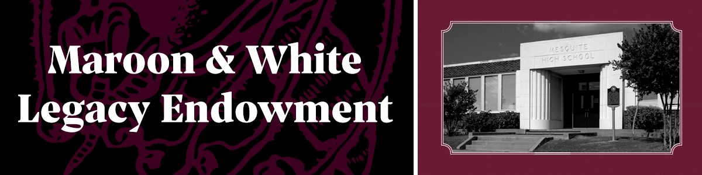
MESQUITE HS L BUILDING BRICK CAMPAIGN
BRICK PERSONALIZATION FORM

As a donor to the Mesquite High School Maroon & White Legacy Endowment you are entitled to receive a personalized, commemorative L Building Brick as a keepsake for your home or office.

Please use this form to personalize the plaque on your brick. This personalization will also be used on the permanent donor recognition display to be installed inside L Building. Please allow 4-6 weeks for your brick to be completed. You will be contacted by the Education Foundation upon completion.

Donor Name:
Street Address:
City: |  |  | State: |  | Zip:
Phone:
Email:

Please enter text in the table below exactly how you would like it to appear on your plaque. Type or print clearly in black ink. Each letter, symbol and space counts as a character. You may have a maximum of 25 characters per row. You may have no more than three rows.

1 | 2 | 3 | 4 | 5 | 6 | 7 | 8 | 9 | 10 | 11 | 12 | 13 | 14 | 15 | 16 | 17 | 18 | 19 | 20 | 21 | 22 | 23 | 24 | 25

SAMPLE IMAGE
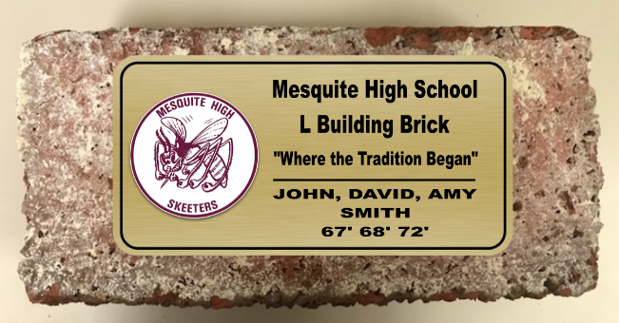

Please return this completed form via mail or email to:
Mesquite ISD Education Foundation
P.O. Box 871385
Mesquite, TX 75150
972-882-8779
hlewallyn@mesquiteisd.org

